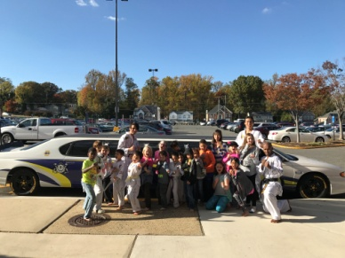
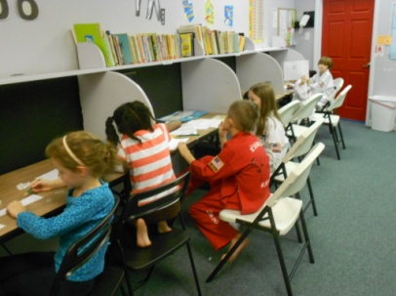
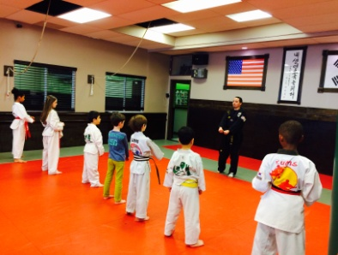
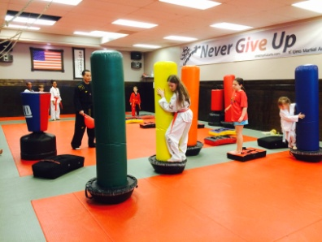

Before School Hours: Doors open at 7a.m.
After School Hours: Pick-up by 6:30 p.m.
*Transportation provided from local schools (even on half-days)
* Early release pick up, NO extra charge
*Trained, enthusiastic, and caring staffs
* Tae Kwon Do classes, providing your child with a character building education
* Discipline training, homework time, snack time, and more!
* On FCPS Teacher Work Day, we offer Day Camp from 7:30am to 6:30pm!

It’s Fun! It’s Educational! It’s Affordable! Students grow, learning Respect & Responsibility!
It’s Not Day Care – It’s So Much More!

After School Prices
ONE time  Registration Fee of $120 $90 | Include :  Uniform, Patches, TKD Bag, UMS Magnets,
$139 a week $104.25 | 3 to 5 days
$90 a week $80 | 2 days
$50 a week | 1 day
Before School Prices
$ 99 | 3 to 5 days
$ 75 | 2 days
$ 50 | 1 day
Before & After School Program Prices
$160 | 3 to 5 days
$120 | 2 days
$70 | 1 days

6349 Columbia Pike, # C, Falls Church, VA 22041
umsmartialarts@gmail.com * Tel: 703-914-1110 umsKICK.com

