Take a TAE KWON DO lesson!
COST:
10 Child Minimum: $249!
Each Additional Child: $10
Adults: Free!!
(Additional birthday child’s trophy is $15.00)

Every child gets to break a BOARD!
Birthday child gets a shiny TROPHY!
Climbing up the ROPE (Parents are invited too)
Cut your cake with a SWORD!
Play in our MOON BOUNCE!
- Each child gets 2 WEEKS FREE Taekwondo Lessons!!

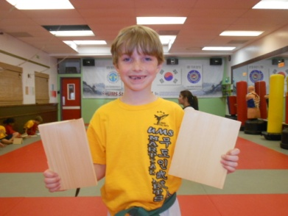
Birthday’s Person Name/s: __________________________________
Child’s Name

Guardian’s Name (s): ______________________________________

Phone: ___________________________________________________

Email: ___________________________________________________
The Party will be on: ___/___/___ Day: Saturday
Party Time: 3:30 pm to 5:00 pm (1 hour 30 minutes)

Terms and Conditions
Parents/organizers can arrive at 1:45 pm to set up food and/or decorations and cake, if they need to. Parents/organizers will be responsible for the children whose parents are not present at the party. Payment of $249 is required to make the reservation. In case of a reschedule or cancelation of the party for any reason, Parents or organizers must notify UMS by the Monday (before 6:00 pm) before the date of the party listed above, and will receive fifty percent of the deposit amount back, otherwise there will be no refund. If there are more than ten children at the party, Parents/organizers will pay the additional amount ($10 for each additional child) on the day of the party.

_______________________________________
Guardian signature is required

OFFICCE USE ONLY | Type |  | Amount | Date | Initial
Deposit: | CASH.#
Amount Remanding: | Credit Card. #
Received by: | Check. #
How many additional children? |  | How many breaking boards?
Additional Amount Paid:$_____ ______  CASH # .  Credit Card # .  Check # . |  | How many trophies? 1 2 3  (Additional birthday child’s trophy is $15.00)  Note:_____________________________________________  _________________________________________________
 |  | Date / / Day:
Parent’s signature :_____________________ |  | Master /Director:_____________________

